EdgeBook

Brand Guidelines

© 2025 / All rights reserved

Table of contents

1. Overview

Key brand foundations, including an overview of the company, its voice, vision, and tagline.

03 - 04

1. Logo
2. Colors
3. Typography
4. Applications

This section covers the logo design, including its construction, variations, clear space, and usage guidelines.

Brand’s color palee, including primary and Grayscale colors, usage guidelines.

Primary and secondary typefaces, usage hierarchy, and styling guidelines

Applications across various touchpoints, demonstrating how the logo should be used in real-world scenarios

05 - 11

12 - 14

15 - 17

18 - 19

EdgeBook © 2025 / All rights reserved 02

# Overview

O1

© 2025 / All rights reserved

## Overview

Brand Vision  Brand Voice 

EdgeBook is the ultimate social platform for sports enthusiasts, empowering both professional and amateur beors to connect, predict, and proﬁt. We aim to revolutionize sports analytics by blending the power of community sentiment with cuing-edge AI insights from GameLens, oering users a comprehensive toolkit to anticipate outcomes and enhance their being edge. Driven by the values of innovation, transparency, and empowerment, EdgeBook fosters a dynamic and inclusive community where predictions turn into victories. We stand for the democratization of sports being analytics by providing an engaging, modern platform that celebrates the diverse voices of sports fans globally. By embracing user insights and enhancing predictive accuracy, we are poised to become the go-to destination for sports being enthusiasts seeking to proﬁt from their passion.

Edgy, Innovative, Empowering, Playful, Insightful, Engaging, Expert-Driven, Youthful, Conﬁdent, Cultivated

EdgeBook

© 2025 / All rights reserved 04

# Logo

O2

© 2025 / All rights reserved

## Logo

#### Primary

The primary logo is the main representation of the brand and should be used in most situations. It reﬂects the brand’s full identity and should appear in prominent placements such as websites, presentations, and marketing materials.

EdgeBook

© 2025 / All rights reserved 06

## Logo

#### Secondary

The secondary logo maintains the same design as the primary logo but is presented in an alternate color variation. It is used when the primary color does not suit the background or speciﬁc visual context.

EdgeBook

© 2025 / All rights reserved 07

## Logo

#### Tiertiary

The tertiary logo is another color variation of the primary logo, designed to provide additional ﬂexibility across dierent backgrounds and applications while maintaining brand consistency.

EdgeBook

© 2025 / All rights reserved 08

## Logo Mark

Here are the three logo mark variations, primary, secondary, and tertiary. Each shown in a dierent color to ensure versatility and consistency across various backgrounds and use cases.

EdgeBook

#### Primary Secondary Tiertiary

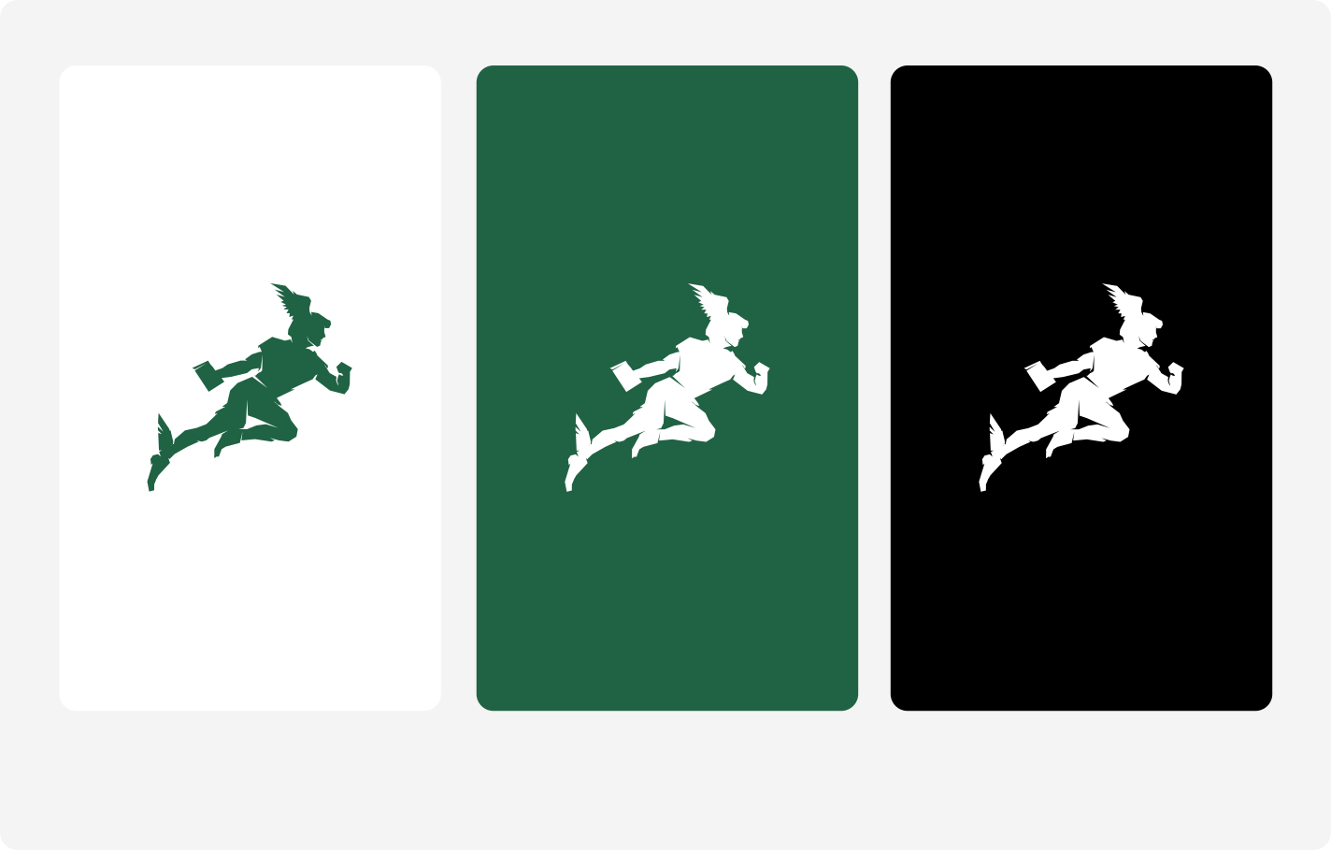© 2025 / All rights reserved 09

## Logo Clearspace

1/4

1/4

The logo clear space is deﬁned as one-quarter (1/4) of the logo’s total height. This area must remain free of any text, graphics, or other visual elements to ensure the logo maintains its visual impact and legibility across all applications.

EdgeBook

© 2025 / All rights reserved 10

## Logo Clearspace

|  |  |  |
| --- | --- | --- |
| 1/4 |  | |
|  |  |  |
|  | | 1/4 |

The logo clear space is deﬁned as one-quarter (1/4) of the logo’s total height. This area must remain free of any text, graphics, or other visual elements to ensure the logo maintains its visual impact and legibility across all applications.

EdgeBook

© 2025 / All rights reserved 11

# Colors

O3

© 2025 / All rights reserved

## Colors

HEX

#FFFFFF

HEX

#000000

#### Primary Colors

The colors shown here are the primary colors of the brand and serve as the foundation for all visual communications. These hues should be used consistently across all print and digital materials to maintain a cohesive and recognizable brand identity.

HEX

#206344

EdgeBook

© 2025 / All rights reserved 13

## Colors

Grayscale Color - 01

### Cloud

Grayscale Color - 02

### Smoke

Grayscale Color - 03

### Steel

Grayscale Color - 04

### Space

HEX #EDEFF7

HEX #D3D6E0

HEX #BCBFCC

HEX #9DA2B3

Grayscale Color - 05

### Graphite

Grayscale Color - 06

### Arsenic

Grayscale Color - 07

### Phantom

Grayscale Color - 08

### Black

#### Grayscale Colors

A grayscale color palee consists of varying shades of gray, ranging from pure black to white, with all the intermediate tones in between. The palee doesn’t contain any hue or color, it only varies in lightness or darkness.

HEX #6E7180

HEX #40424D

HEX #1E1E24

HEX #000000

EdgeBook

© 2025 / All rights reserved 14

# Typography

O4

© 2025 / All rights reserved

## Typography Manrope

Light

##### ABCDEFGHIJKLMNOPQRSTUVWXYZ

abcdefghijklmnopqrstuvwxyz0123456789° (!"#$%&?@)

Regular

Medium

Semibold

##### ABCDEFGHIJKLMNOPQRSTUVWXYZ

abcdefghijklmnopqrstuvwxyz0123456789° (!”#$%&?@)

##### ABCDEFGHIJKLMNOPQRSTUVWXYZ

abcdefghijklmnopqrstuvwxyz 0123456789° (!"#$%&?@)

##### ABCDEFGHIJKLMNOPQRSTUVWXYZ

abcdefghijklmnopqrstuvwxyz 0123456789° (!”#€%&?@)

This font represents the brand’s primary typography and should be used across all communications to ensure a consistent and professional visual identity.

EdgeBook

Bold

ExtraBold

##### ABCDEFGHIJKLMNOPQRSTUVWXYZ

abcdefghijklmnopqrstuvwxyz 0123456789° (!”#€%&?@)

##### ABCDEFGHIJKLMNOPQRSTUVWXYZ

abcdefghijklmnopqrstuvwxyz 0123456789° (!"#$%&?@)

© 2025 / All rights reserved 16

## Typography Type Scaling

64 Px

48 Px

32 Px

Heading 1

Heading 2

Subheader 1

Typography scaling ensures a consistent and harmonious visual hierarchy across all brand materials. By applying proportional size relationships between headings, subheadings, body text, and captions, we maintain readability while reinforcing brand identity. This system allows type to adapt seamlessly across dierent formats and devices, ensuring clarity and cohesion in every application.

24 Px

18 Px

16 Px

#### Subheader 2

Paragraph 1

Paragraph 2

EdgeBook

© 2025 / All rights reserved 17

# Applications

O5

© 2025 / All rights reserved

## Applications

This section demonstrates how the brand’s visual elements, logo, typography, color palee, and imagery are applied across various touchpoints.

EdgeBook



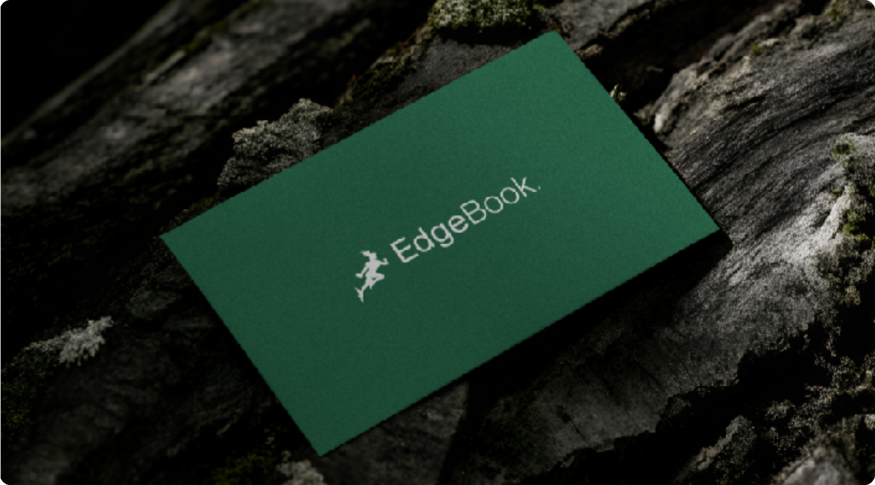© 2025 / All rights reserved 19



# Thank You

© 2025 / All rights reserved